A panel of DNA methylation signature from peripheral blood may predict colorectal cancer Susceptibility
Supplementary Tables and Figures

Table S1 Top Gene Ontology Enrichment Analysis of Differentially Methylated Genes of Nested Case Control Study Based on EPIC-Italy Cohort
ID | Term | Ontology | Gene counts | FDR
GO:0005515 | protein binding | MF | 11397 | 7.76E-57
GO:0005737 | cytoplasm | CC | 11184 | 2.11E-45
GO:0031234 | cytoplasmic part | CC | 9394 | 3.59E-42
GO:0005488 | binding | MF | 14573 | 6.93E-42
GO:0005622 | intracellular | CC | 14620 | 6.96E-41
GO:0044424 | intracellular part | CC | 14311 | 3.78E-40
GO:0071841 | cellular component organization or biogenesis | BP | 6285 | 1.40E-34
GO:0043226 | organelle | CC | 13429 | 2.38E-34
GO:0043229 | intracellular organelle | CC | 12623 | 3.89E-32
GO:0016043 | cellular component organization | BP | 6114 | 7.02E-32
GO:0098772 | molecular function | MF | 16827 | 4.92E-31
GO:0044446 | intracellular organelle part | CC | 9351 | 1.14E-30
GO:0044464 | cell part | CC | 16486 | 6.08E-30
GO:0044422 | organelle part | CC | 9640 | 8.06E-30
GO:0005623 | cell | CC | 16518 | 8.87E-30
GO:0005829 | cytosol | CC | 4991 | 4.99E-29
GO:0043227 | membrane-bounded organelle | CC | 12390 | 3.34E-28
GO:0043231 | intracellular membrane-bounded organelle | CC | 10904 | 1.88E-25
GO:0051641 | cellular localization | BP | 2798 | 7.77E-25
GO:0005654 | nucleoplasm | CC | 3454 | 3.43E-24
Abbreviations: BP, Biological Process; CC, Cellular components; MF, Membrane function; FDR: false discovery rate

Table S2 KEGG Pathway Enrichment Analysis of Nested Case Control Study Based on EPIC-Italy Cohort
ID | Pathway | Gene counts | FDR
hsa04015 | Rap1 signaling pathway | 206 | 0.0004
hsa04218 | Cellular senescence | 157 | 0.0012
hsa01100 | Metabolic pathways | 1231 | 0.0012
hsa04360 | Axon guidance | 180 | 0.0021
hsa00970 | Aminoacyl-tRNA biosynthesis | 44 | 0.0032
hsa04152 | AMPK signaling pathway | 119 | 0.0048
hsa05200 | Pathways in cancer | 519 | 0.0066
hsa04110 | Cell cycle | 124 | 0.0078
hsa04115 | p53 signaling pathway | 72 | 0.0149
hsa05203 | Human papillomavirus infection | 320 | 0.0161
Abbreviations: FDR, false discovery rate

Table S3 Differentially Methylated CpGs between Colorectal Cancer and Healthy Normal Subjects of Nested Case Control Study Based on EPIC-Italy Cohort
CpG ID | Chr¹ | Position | Gene Name | Gene Group | Relation to Island | Delta β² | Q- value³
cg00325531 | 1 | 75591353 | NA | NA | Island | -0.06 | 1.72E-02
cg01066472 | 1 | 75591029 | NA | NA | Island | -0.05 | 9.78E-03
cg06825163 | 1 | 202172912 | LGR6;LGR6;LGR6 | 1stExon;Body;  5'UTR | OpenSea | -0.05 | 1.00E-02
cg12691488ª | 1 | 243053673 | NA | NA | Island | 0.05 | 1.77E-07
cg01620164 | 2 | 164590272 | FIGN | Body | N_Shelf | -0.07 | 8.59E-04
cg16440561 | 2 | 220312854 | SPEG | Body | Island | -0.09 | 5.32E-05
cg19015611 | 2 | 71126446 | VAX2 | TSS1500 | N_Shore | -0.06 | 8.40E-07
cg20144008 | 2 | 173037423 | NA | NA | Island | -0.06 | 1.99E-11
cg26309498 | 2 | 109607038 | EDAR | TSS1500 | OpenSea | -0.05 | 6.81E-06
cg11643285 | 3 | 16411667 | RFTN1 | Body | OpenSea | -0.06 | 2.90E-12
cg11885357 | 3 | 138152902 | ESYT3 | TSS1500 | N_Shore | -0.06 | 1.53E-02
cg17238319 | 3 | 16428391 | RFTN1 | Body | OpenSea | -0.06 | 2.20E-10
cg20432211 | 4 | 77342104 | NA | NA | Island | -0.05 | 2.14E-03
cg12578536 | 5 | 43003251 | NA | NA | S_Shelf | -0.05 | 2.23E-04
cg18022036 | 5 | 19288941 | NA | NA | OpenSea | -0.07 | 8.14E-08
cg05983326 | 5 | 140710688 | PCDHGA1;PCDHGA1 | 1stExon;1stExon | N_Shore | -0.05 | 2.00E-03
cg01419670ª | 5 | 115696151 | NA | NA | N_Shore | 0.06 | 9.82E-10
cg00321614ª | 5 | 172856932 | NA | NA | OpenSea | 0.06 | 7.57E-07
cg10563109 | 6 | 5087749 | NA | NA | S_Shore | -0.05 | 1.08E-05
cg15969227 | 6 | 26745279 | NA | NA | OpenSea | -0.06 | 5.09E-04
cg16500605 | 6 | 31620861 | BAT3;BAT3;BAT3;BAT3 | TSS1500;TSS1500;  TSS1500;TSS1500 | Island | -0.10 | 4.08E-12
cg16170495 | 6 | 30042626 | RNF39;RNF39 | Body;Body | N_Shore | -0.05 | 1.62E-05
cg16101278ª | 6 | 6648823 | LY86 | Body | OpenSea | 0.10 | 1.14E-12
cg06551493 | 7 | 77166702 | PTPN12;PTPN12;PTPN12 | TSS200;TSS1500;  TSS1500 | Island | -0.06 | 1.24E-09
cg04205664 | 7 | 139209511 | CLEC2L | Body | S_Shore | 0.10 | 3.20E-12
cg03151810 | 8 | 144371745 | NA | NA | Island | 0.07 | 1.48E-03
cg03894796 | 8 | 144361315 | NA | NA | Island | 0.05 | 1.54E-05
cg11240062 | 8 | 144361073 | NA | NA | Island | 0.08 | 2.26E-05
cg11388673 | 8 | 144371779 | NA | NA | Island | 0.06 | 8.00E-04
cg07044115 | 10 | 123100181 | NA | NA | OpenSea | -0.05 | 3.51E-02
cg09656541 | 10 | 115932823 | C10orf118 | 5'UTR | N_Shore | 0.05 | 1.33E-05
cg08829299 | 11 | 288305 | ATHL1 | TSS1500 | N_Shore | -0.06 | 3.10E-02
cg21585512 | 11 | 122030076 | LOC399959 | Body | OpenSea | -0.07 | 2.46E-04
cg21565415 | 11 | 618993 | MUPCDH;MUPCDH | Body;Body | S_Shore | 0.07 | 9.91E-10
cg24702253 | 11 | 3240068 | MRGPRG;C11orf36 | TSS200;Body | S_Shore | 0.07 | 5.08E-04
cg03691818 | 12 | 53085038 | KRT77 | Body | OpenSea | -0.08 | 2.69E-12
cg23256579 | 12 | 11002403 | PRR4;PRR4 | TSS1500;Body | OpenSea | -0.09 | 1.62E-09
cg16530981 | 12 | 42679156 | NA | NA | N_Shore | 0.06 | 1.62E-08
cg06710937 | 13 | 23489940 | NA | NA | Island | -0.06 | 2.61E-09
cg11057824 | 14 | 50471938 | C14orf182 | Body | S_Shore | 0.06 | 2.65E-06
cg12101586 | 15 | 75019203 | CYP1A1 | TSS1500 | Island | -0.06 | 4.05E-05
cg22549041 | 15 | 75019251 | CYP1A1 | TSS1500 | Island | -0.05 | 6.73E-04
cg26921482 | 16 | 2570283 | AMDHD2;AMDHD2 | TSS200;TSS200 | Island | -0.06 | 5.26E-10
cg04946709 | 16 | 59789030 | LOC644649 | Body | Island | 0.07 | 1.99E-11
cg17292758 | 19 | 49636594 | PPFIA3 | Body | Island | -0.06 | 4.88E-06
cg00157199 | 20 | 29551622 | NA | NA | Island | -0.08 | 3.13E-04
cg14815891 | 20 | 29611903 | FRG1B | Body | Island | -0.06 | 1.67E-02
cg17187762 | 22 | 28070120 | NA | NA | N_Shelf | -0.05 | 1.83E-03
Abbreviations: ¹Chr, Chromosome; ²Delta β: Absolute mean β-value difference (delta beta ≥ 0.05); ³Q- value: False discovery rate, (FDR < 0.05
Table S4 Univariate Analysis on the Associations of DNA Methylation Marker, MRS and Risk of CRC of Nested Case Control Study Based on EPIC-Italy Cohort
 |  |  | Entire Dataset |  |  |  |  |  | Training Dataset |  |  |  | Testing Dataset
CpG ID | Gene Name |  | OR | 95% CI | P-value |  |  | OR | 95% CI | P-value |  | OR | 95% CI | P-value
cg06551493 | PTPN12 |  | 0.49 | 0.39, 0.60 | 2.78e-11 |  |  | 0.58 | 0.45, 0.74 | 1.07e-05 |  | 0.30 | 0.19, 0.46 | 1.73e-07
cg01419670 | NA |  | 2.51 | 1.94, 3.33 | 2.02e-11 |  |  | 2.64 | 1.94, 3.73 | 4.95e-09 |  | 2.22 | 1.43, 3.72 | 9.72e-04
cg16530981 | NA |  | 2.23 | 1.76, 2.89 | 2.53e-10 |  |  | 2.36 | 1.77, 3.22 | 1.62e-08 |  | 1.95 | 1.28, 3.19 | 3.74e-03
cg18022036 | NA |  | 0.52 | 0.42, 0.64 | 1.07e-09 |  |  | 0.52 | 0.40, 0.66 | 2.58e-07 |  | 0.53 | 0.36, 0.77 | 1.10e-03
cg12691488 | NA |  | 1.74 | 1.46, 2.08 | 8.11e-10 |  |  | 1.52 | 1.23, 1.87 | 8.09e-05 |  | 2.43 | 1.73, 3.48 | 6.10e-07
cg17292758 | PPFIA3 |  | 0.59 | 0.49, 0.72 | 6.68e-08 |  |  | 0.63 | 0.50, 0.79 | 4.82e-05 |  | 0.50 | 0.34, 0.72 | 2.94e-04
cg16170495 | RNF39 |  | 0.62 | 0.51, 0.74 | 2.92e-07 |  |  | 0.65 | 0.52, 0.80 | 1.05e-04 |  | 0.55 | 0.38, 0.77 | 6.31e-04
cg11240062 | NA |  | 1.71 | 1.41, 2.10 | 1.43e-07 |  |  | 1.64 | 1.30, 2.086 | 3.76e-05 |  | 1.94 | 1.34 2.92 | 8.48e-04
cg21585512 | LOC399959 |  | 0.64 | 0.52, 0.77 | 4.44e-06 |  |  | 0.54 | 0.42, 0.69 | 6.60e-07 |  | 0.92 | 0.66, 1.28 | 0.61
cg24702253 | MRGPRG |  | 2.04 | 1.49, 3.02 | 6.94e-05 |  |  | 2.04 | 1.42, 3.26 | 6.77e-04 |  | 2.07 | 1.19, 4.79 | 3.82e-02
cg17187762 | NA |  | 0.69 | 0.57, 0.83 | 7.23e-05 |  |  | 0.70 | 0.56, 0.87 | 1.46e-03 |  | 0.66 | 0.47, 0.92 | 1.67e-02
cg05983326 | PCDHGA1 |  | 0.68 | 0.56, 0.82 | 8.39e-05 |  |  | 0.70 | 0.55, 0.87 | 1.64e-03 |  | 0.65 | 0.45, 0.92 | 1.75e-02
cg06825163 | LGR6 |  | 0.72 | 0.59, 0.87 | 5.82e-04 |  |  | 0.70 | 0.56, 0.88 | 2.33e-03 |  | 0.75 | 0.53, 1.05 | 0.10
cg11885357 | ESYT3 |  | 0.73 | 0.61, 0.88 | 9.91e-04 |  |  | 0.71 | 0.57, 0.88 | 2.14e-03 |  | 0.80 | 0.57, 1.12 | 0.20
cg08829299 | ATHL1 |  | 0.75 | 0.62, 0.90 | 2.36e-03 |  |  | 0.76 | 0.61, 0.95 | 1.62e-02 |  | 0.72 | 0.50, 1.01 | 0.06
cg07044115 | NA |  | 0.75 | 0.62, 0.90 | 1.86e-03 |  |  | 0.78 | 0.63, 0.97 | 2.61e-02 |  | 0.67 | 0.47, 0.93 | 0.02
MRS |  |  | 2.55 | 2.15, 3.06 | <0.000 |  |  | 2.72 | 2.21, 3.44 | <0.000 |  | 2.25 | 1.73, 3.07 | < 0.000
Abbreviations: CI, confidence interval; CRC: colorectal cancer; MRS, methylation risk score

Table S5 Correlation between DNA Methylation Marker and Time-To-Diagnosis of Nested Case Control Study Based on EPIC-Italy Cohort
CpG ID | Gene Name | Estimate (r) | P-value
cg06551493 | PTPN12 | -0.10 | 0.18
cg01419670 | NA | 0.12 | 0.11
cg16530981 | NA | 0.08 | 1.07
cg18022036 | NA | -0.16 | 0.03
cg12691488 | NA | 0.15 | 0.06
cg17292758 | PPFIA3 | -0.10 | 0.22
cg16170495 | RNF39 | -0.02 | 0.79
cg11240062 | NA | 0.17 | 0.03
cg21585512 | LOC399959 | 0.03 | 0.67
cg24702253 | MRGPRG | 0.06 | 0.43
cg17187762 | NA | 0.01 | 0.92
cg05983326 | PCDHGA1 | 0.11 | 0.15
cg06825163 | LGR6 | -0.12 | 0.14
cg11885357 | ESYT3 | -0.07 | 0.40
cg08829299 | ATHL1 | -0.06 | 0.45
cg07044115 | NA | 0.01 | 0.86

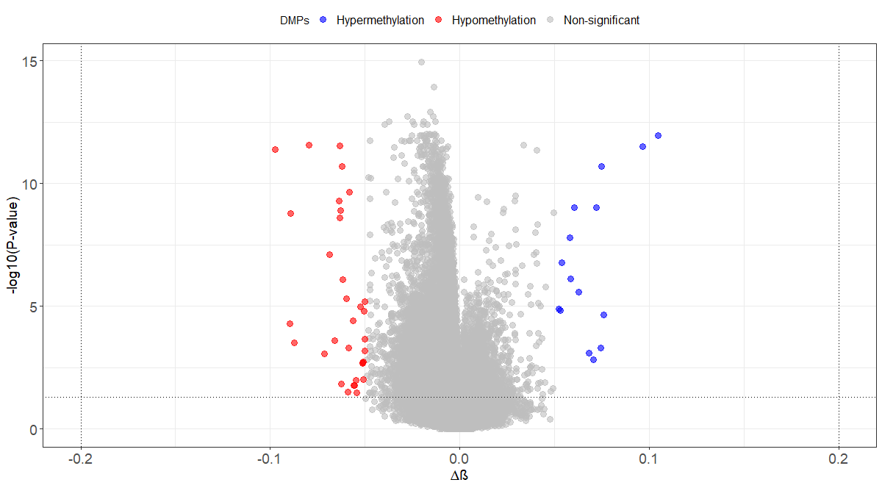
Additional file 1: Figure S1. Volcano plot for differential DNA methylation analysis of all 399,934 CpG sites among 166 CRC and healthy normal subjects. The x-axis shows the mean DNA methylation difference (delta beta), while the y-axis shows the –log10 of the p value for each CpG.

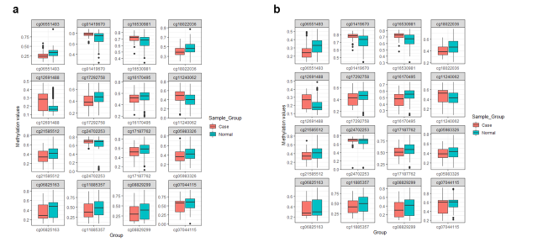 Additional file 5: Figure S2. The distribution of the methylation values of the sixteen risk markers in CRC and healthy normal subjects in the training (a) and testing (b) dataset.

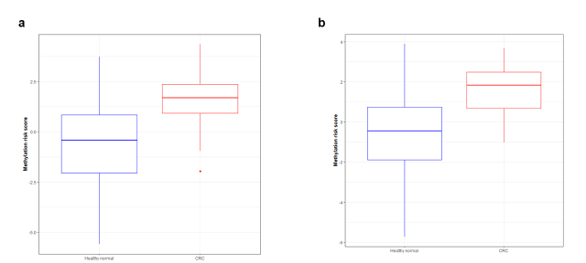 Additional file 7: Figure S3. Box-plots of the MRS separately in CRC and healthy normal subjects for training dataset (Supplementary Figure. S3a) and testing dataset (Supplementary Figure. S3b).

